NAME : OLATUNJI ABDULLAH

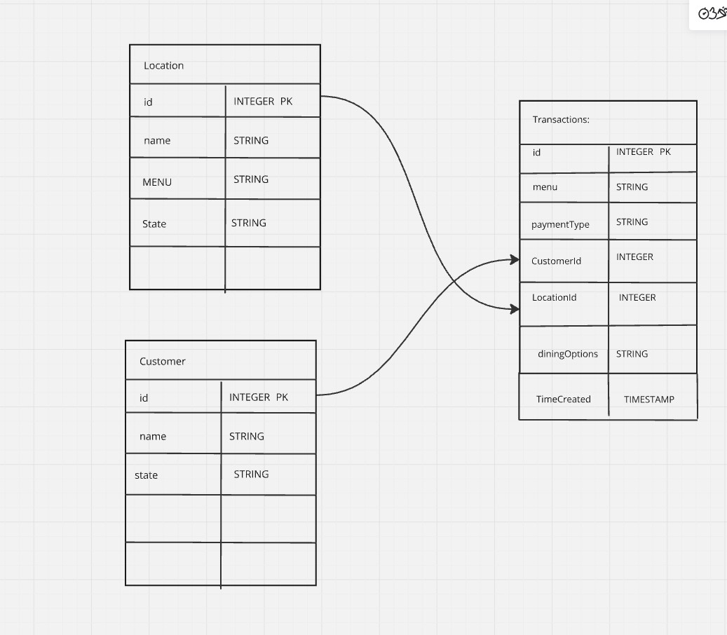

**1.**

Based on the restaurant's operations, the necessary entities, relationships, and constraints for the dimensional model can be defined as follows:

**Entities:**

* **Location**: Each outlet of Fufu Republic, including details like location and menu variations.
* **Menu Items**: Information on food
* **Sales Transactions**: For each sale event, capture details of date, location, customer, and payment method.
* **Customer**: Captures customer details for personalized promotions.
* **Payment Method**: Records payment types (cash, POS, online).
* **Inventory**: Represents the stock levels of menu items at various locations.

**Relationships:**

* **Location** has many **Sales Transactions**.
* **Each Menu Items** are linked to **Sales Transactions** (each transaction has one or more items).
* **Sales Transactions** are linked to **Customers**.
* **Each Sales Transaction** is linked to a **Payment Method**.
* **Inventory** of menu items is tracked at each location.

**Constraints:**

* Each transaction must be associated with a valid Location and payment method.
* Customers should have valid IDs when they make an order.
* Inventory must be updated after each transaction to avoid stockouts.

**2. Creating a Dimensional Model**

**Business Process Chosen: Sales Monitoring and Inventory Management**

The goal is to analyze sales trends and manage stock across locations based on customer preferences and demand patterns.

**Business Questions:**

* What are the most popular menu items across different locations?
* How do payment methods vary across locations?
* Which Location is experiencing the highest sales?
* How can we predict stock depletion to avoid shortages?

**Grain:**

The grain will be at the **sales transaction** level, which represents each order or sale made by a customer.

**Dimensions:**

* **Date Dimension**: Date and time details of the transaction (day, month, year).
* **Location Dimension**: Details about each Location (e.g., location, region).
* **Customer Dimension**: Information on customers, including their purchasing behavior and demographics.
* **Payment Method Dimension**: The method used for the transaction (cash, POS, online).
* **Menu Item Dimension**: Details about each menu item (e.g., item name, category, price).

**Some Details About The Table:**

* **Sales Fact Table**: Contains the transaction details for each sale.
  + **Foreign Keys**: Links to the Location, customer, payment method, and menu items.
  + **Measures**:
    - Total sales amount (for the transaction).
    - Quantity sold.
    - Discounts or promotions applied (if any).
    - Stock levels affected by the sale.